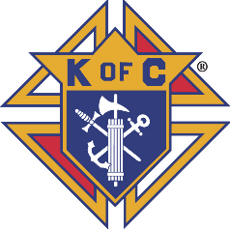
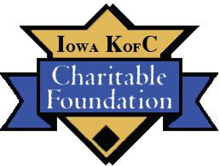
Iowa Knights of Columbus

Charitable Foundation

APPLICATION FOR FUNDING

Person Requesting Funds:

󠄀 Grand Knight 󠄀Faithful Navigator Council / Assembly No. _____________

Name: ____________________________________ Date: ___________________________

Address ___________________________________ Phone Number: ___________________
(Use number format like this: XXX-XXX-XXXX)
City_______________________ Zip Code __________

Has the requesting party (council or assembly) previously applied for a grant? YES NO I DON'T KNOW

FOUNDATION FUND (check most applicable):

󠄀 General Fund
󠄀 Helping Hands Fund 󠄀 Vocations and Catholic Education Fund*
󠄀 Culture of Life Fund 󠄀 Persons with Intellectual Disabilities Fund*

* (Limited funds are also available from the Iowa KofC State Council by submitting a written request to the State Deputy)
Party in Need:
Name of Party in Need: |  |  |  |  |  |  | Phone Number:
 |  |  |  |  |  |  | (Use number format like this: XXX-XXX-XXXX)
Address
City |  |  |  | Zip Code
Has the Party in Need previously applied for a grant? |  |  |  |  |  | YES | NO

Purpose of Request:

Description (purpose, needs to be met, etc.

Continued on next page
Purpose of Request (cont.):

Continue description (purpose, needs to be met, etc.)

Total cost of the activity/ project? _______________ 󠄀 Unknown

Amount funded by Council/ Assembly? _______________ 󠄀 Unknown

What percentage of the total project is being funded by other sources? ___________%
Who are the other sources?

Amount being requested from the Charitable Foundation _______________ 󠄀 Unknown

Date Funds are needed ___________________

Comments/ Additional Information:

When you have completed the entire form, email (preferred) to foundation@iowakofc.org or mail to:

Iowa KC Charitable Foundation, Inc.

Jim Murphy
7811 Twin Lakes Road
Manson, Iowa 50563

